Ex. No. 10 | Manual User Login Authentication using Google Firestore Database
Date of Exercise | 01-11-2025

Github Code Link

Video Link

Aim:
Develop a Flutter application that allows user login using email + password stored in Firestore, with a clean and professional UI design.
Description:
- Google Cloud Firestore is a NoSQL cloud database service provided by Google as part of the Firebase platform, designed to handle scalable and real-time data access for mobile and web applications.
- The users collection is pre-filled manually using the Firebase Console. Each document in this collection contains the fields: name (String), email (String), phone (String), password (String).
- The app verifies login credentials by fetching and matching the entered email and password directly from Firestore. The Firestore where() method is used to filter and retrieve documents based on conditions, the pushReplacement() is used to navigate to dashboard.
Where() Syntax:
FirebaseFirestore.instance
.collection('users')
.where('email', isEqualTo: enteredEmail)
.get();
pushReplacement() Syntax:
Navigator.pushReplacement(
context,
MaterialPageRoute(
builder: (context) => SecondScreen(userName: user['name']),
),);
Integration of Google Firestore in Flutter
- Install Android Studio and create an Android Virtual Device (AVD) or connect a real device for testing.
- Create a Flutter project in VS Code or Android Studio.
- Create or use an existing Firebase project in the Firebase Console.
- Add the Flutter app to Firebase, download the google-services.json file, and place it inside the android/app/ directory.
- Enable Cloud Firestore from Build → Firestore Database → Create Database in Firebase Console.
Gradle Configuration
- Project-Level build.gradle
buildscript {
repositories {
google()
mavenCentral()
}
dependencies {
classpath("com.google.gms:google-services:4.4.1")
}
}
- App-Level build.gradle
plugins {
id("com.google.gms.google-services")
}
android {
ndkVersion = "27.0.12077973"
}
defaultConfig {
minSdk = 23
}
dependencies {
implementation(platform("com.google.firebase:firebase-bom:34.3.0"))
}
- Pubspec Dependencies
dependencies:
flutter:
sdk: flutter
firebase_core: ^3.4.0
cloud_firestore: ^5.4.4

Question:
Create a Flutter application with the following features:
- Manually create users Collection in Google Firestore (based on Exercise 7)
Manually store the following user details inside Firestore Database under a collection named users with the fields:
- name (String)
- email (String)
- phone (String)
- password (String – stored as plain text or hashed)
- User Login Screen
Create UI screen for login with:
- Email (TextField)
- Password (TextField)
- “Login” button
- On Login:
- Fetch the Firestore users collection.
- Match entered email &amp; password manually.
- If valid → go to User Dashboard Page showing “Welcome, <user name>
- Else → show error message (Invalid email or password)

Program:
Main.dart
import 'package:flutter/material.dart';
import 'package:cloud_firestore/cloud_firestore.dart';
import 'package:firebase_core/firebase_core.dart';
import 'secondscreen.dart';
void main() async {
WidgetsFlutterBinding.ensureInitialized();
await Firebase.initializeApp();
runApp(const MaterialApp(
debugShowCheckedModeBanner: false,
home: LoginScreen(),
));
}
class LoginScreen extends StatefulWidget {
const LoginScreen({super.key});
@override
State<LoginScreen> createState() => _LoginScreenState();
}
class _LoginScreenState extends State<LoginScreen> {
final _email = TextEditingController();
final _password = TextEditingController();
String? errorMsg;
Future<void> _login() async {
try {
final snap = await FirebaseFirestore.instance
.collection('users')
.where('email', isEqualTo: _email.text.trim())
.limit(1)
.get();
if (snap.docs.isEmpty) {
setState(() => errorMsg = "Invalid email or password");
return;
}
final user = snap.docs.first.data();
if (user['password'] == _password.text.trim()) {
Navigator.pushReplacement(
context,
MaterialPageRoute(
builder: (_) => SecondScreen(userName: user['name']),
),
);
} else {
setState(() => errorMsg = "Invalid email or password");
}
} catch (e) {
setState(() => errorMsg = "Error: $e");
}
}
@override
Widget build(BuildContext context) {
return Scaffold(
appBar: AppBar(
title: const Text('User Login'),
backgroundColor: const Color.fromARGB(255, 21, 110, 243),
centerTitle: true,
),
body: Padding(
padding: const EdgeInsets.all(20),
child: Column(
mainAxisAlignment: MainAxisAlignment.center,
children: [
Image.network('https://seeddownload.cdn-apple.com/s3/prod/ATLC/package/T050359A-en_US/6d75ff9c-3d23-4978-a6d6-291122a3c718/7.0/T050359A-ecc_p_design_an_app_icon-en_US/src/images/video_intro_video_poster.jpg',height: 150,width: 150,),
SizedBox(height: 20),
TextField(
controller: _email,
decoration: const InputDecoration(
labelText: "Email",
border: OutlineInputBorder(),
),
),
const SizedBox(height: 16),
TextField(
controller: _password,
decoration: const InputDecoration(
labelText: "Password",
border: OutlineInputBorder(),
),
obscureText: true,
),
const SizedBox(height: 24),
ElevatedButton(
onPressed: _login,
style: ElevatedButton.styleFrom(
minimumSize: const Size.fromHeight(45),
backgroundColor: const Color.fromARGB(255, 58, 255, 124)
),
child: const Text('Login'),
),
if (errorMsg != null) ...[
const SizedBox(height: 10),
Text(errorMsg!, style: const TextStyle(color: Colors.red)),
],],
),
),
);
}
}
Secondscreen.dart
import 'package:flutter/material.dart';
class SecondScreen extends StatelessWidget {
final String userName;
const SecondScreen({super.key, required this.userName});
@override
Widget build(BuildContext context) {
return Scaffold(
appBar: AppBar(
title: const Text("User Dashboard",textAlign: TextAlign.center,),
centerTitle: true,
backgroundColor: const Color.fromARGB(255, 21, 110, 243),
automaticallyImplyLeading: true,
),
body: Center(
child: Text(
"Welcome, $userName!",
style: const TextStyle(fontSize: 24, fontWeight: FontWeight.bold),
),
),
backgroundColor:Color.fromARGB(255, 168, 216, 255)
);
}
}
Output Screenshot:
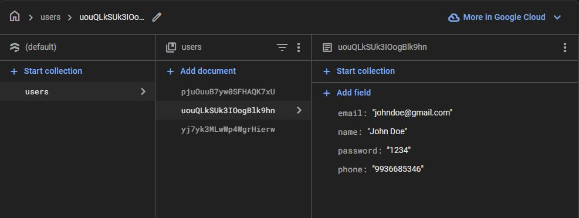
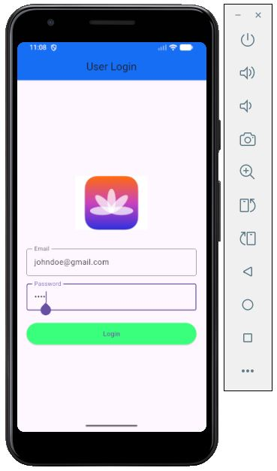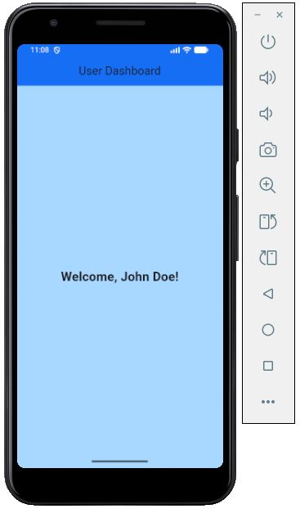

Result:
Thus successfully developed a Flutter application that that allows user login using email + password stored in Firestore, with a clean and professional UI design.

